SB - K6 - Science - Water cycle

1. Storyboard - K6 science - Water cycle

1.1 Storyboard Overview
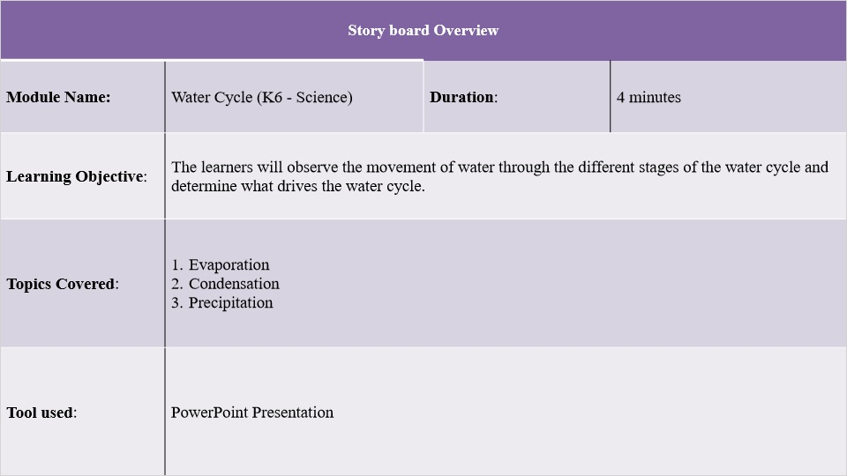

1.2 Slide 1 - Watercycle
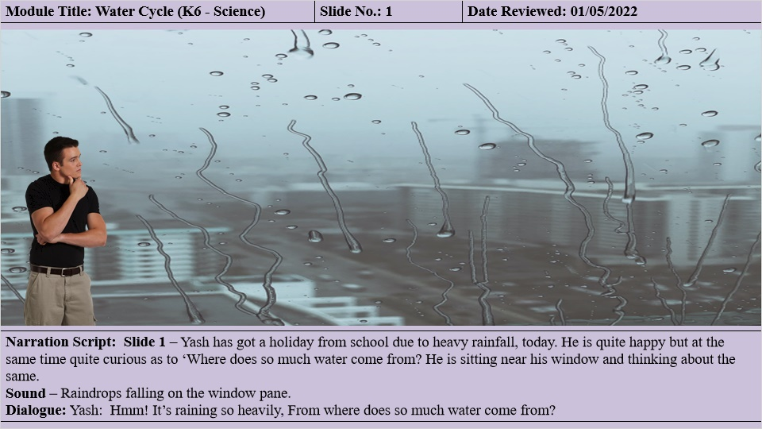

1.3 Slide 2 - Watercycle
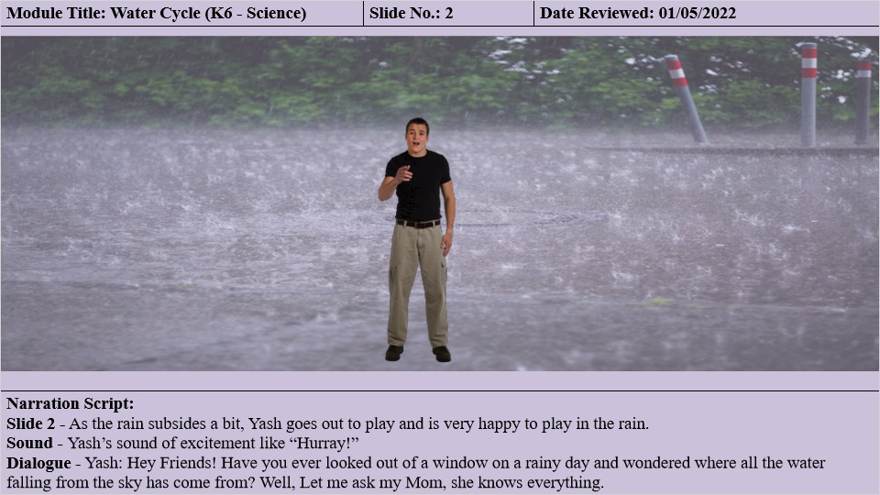

1.4 Slide 3 - Watercycle
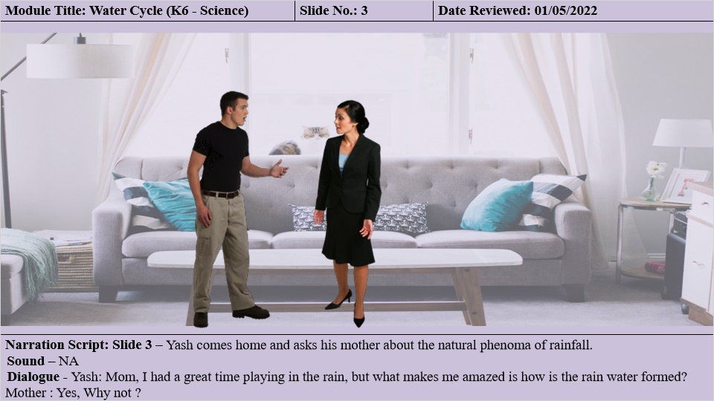

1.5 Slide 4 - Watercycle
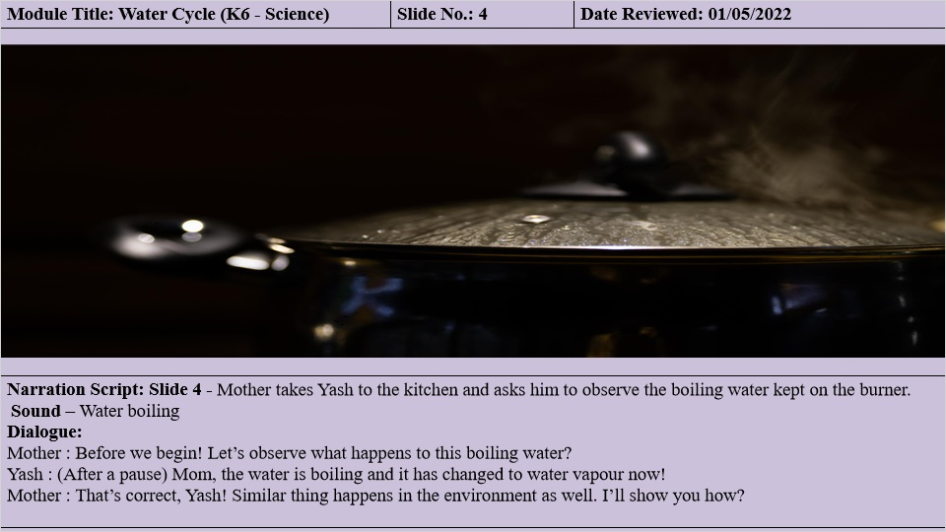

1.6 Slide 5 - Watercycle
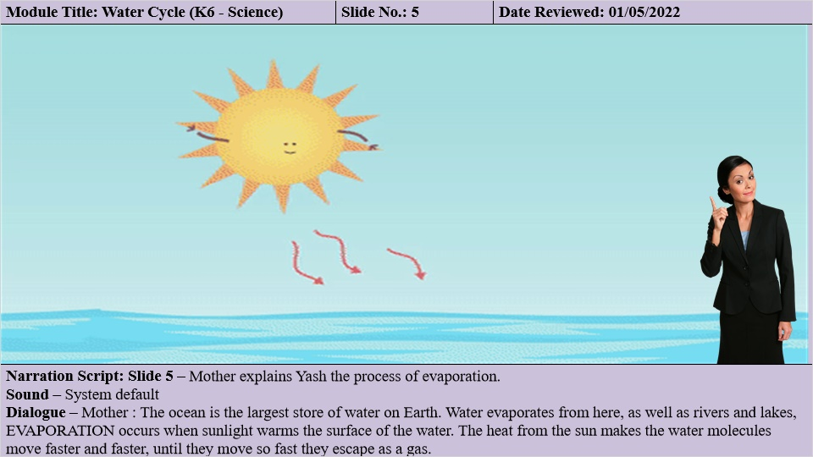

1.7 Slide 7 - Watercycle
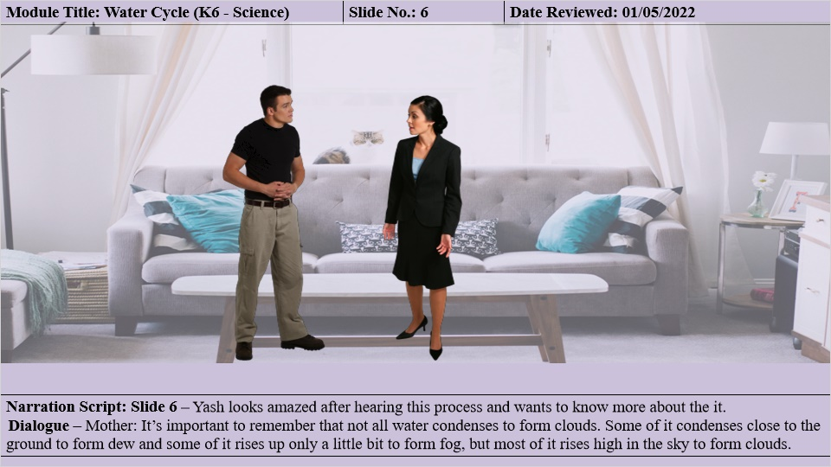

1.8 Slide 8 - Watercycle
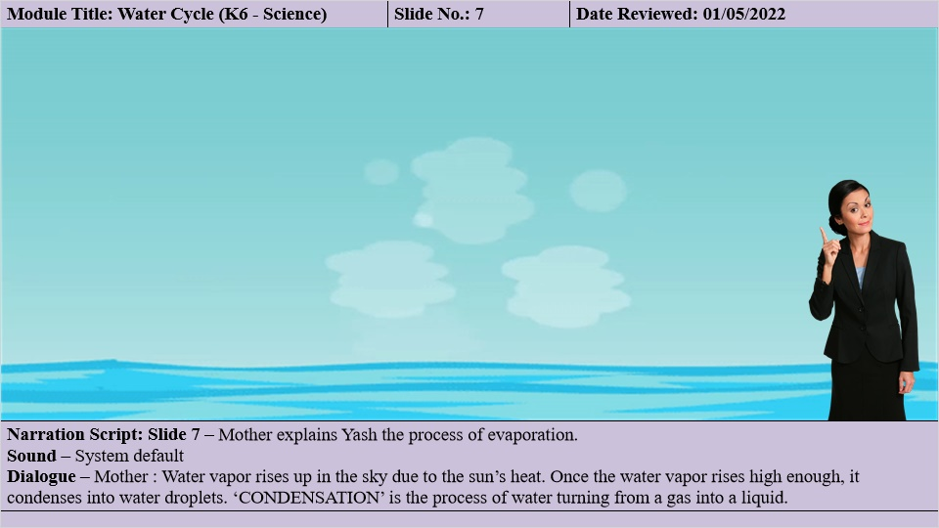

1.9 Slide 9 - Watercycle
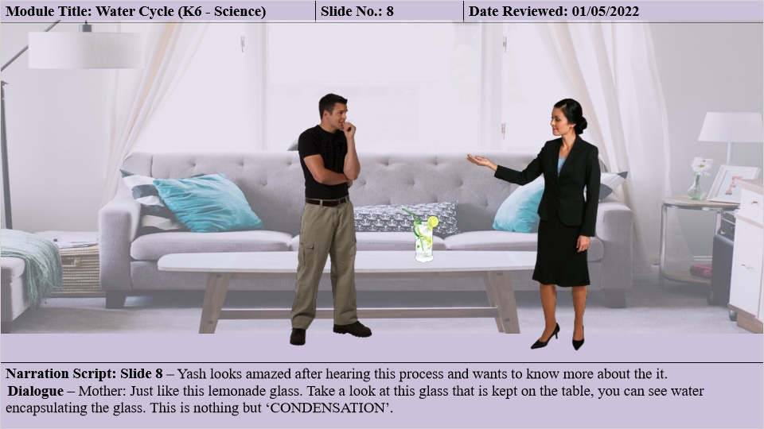

1.10 Slide 10 - Watercycle
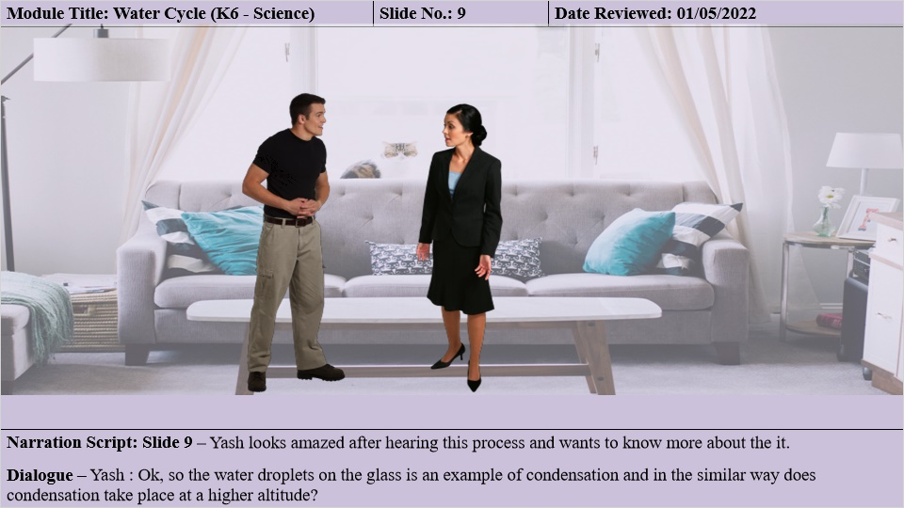

1.11 Slide 11 - Watercycle
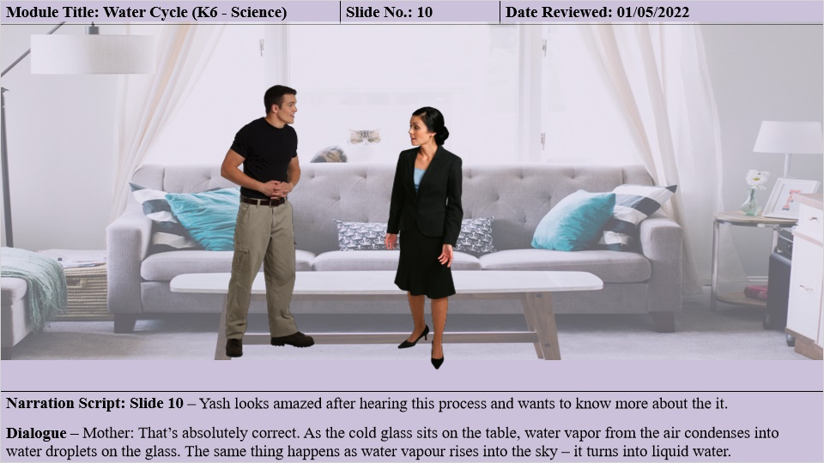

1.12 Slide 12 - Watercycle
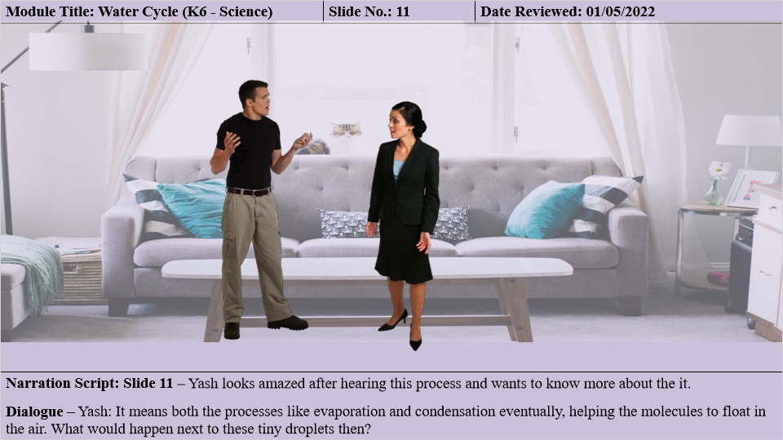

1.13 Slide 13 - Watercycle
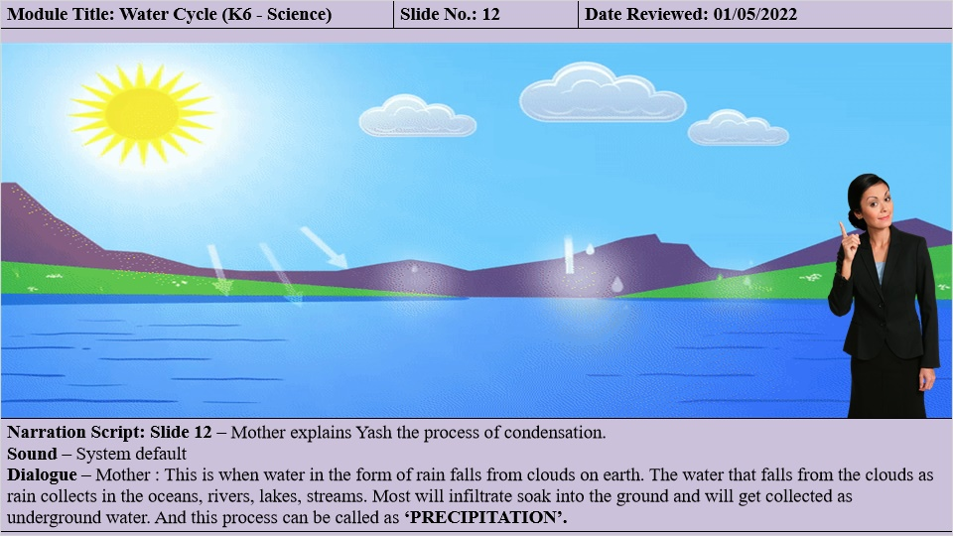

1.14 Slide 14 - Watercycle
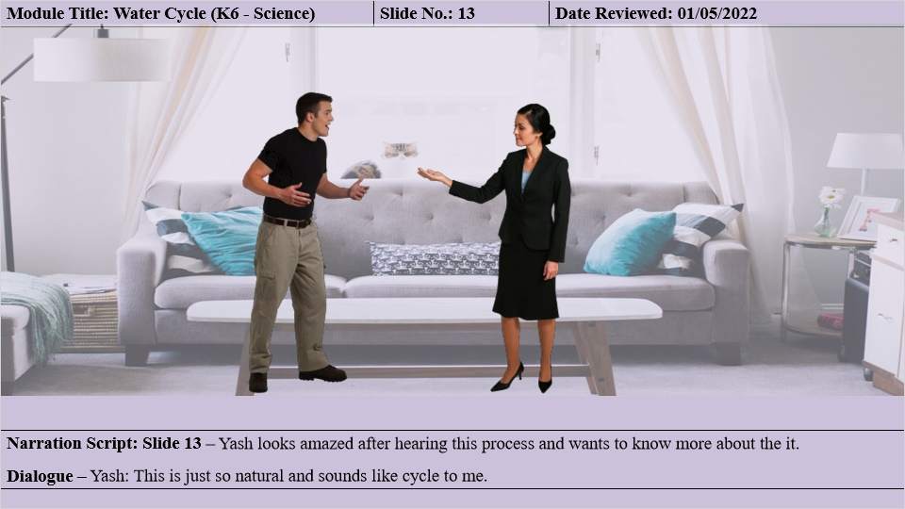

1.15 Slide 15 - Watercycle
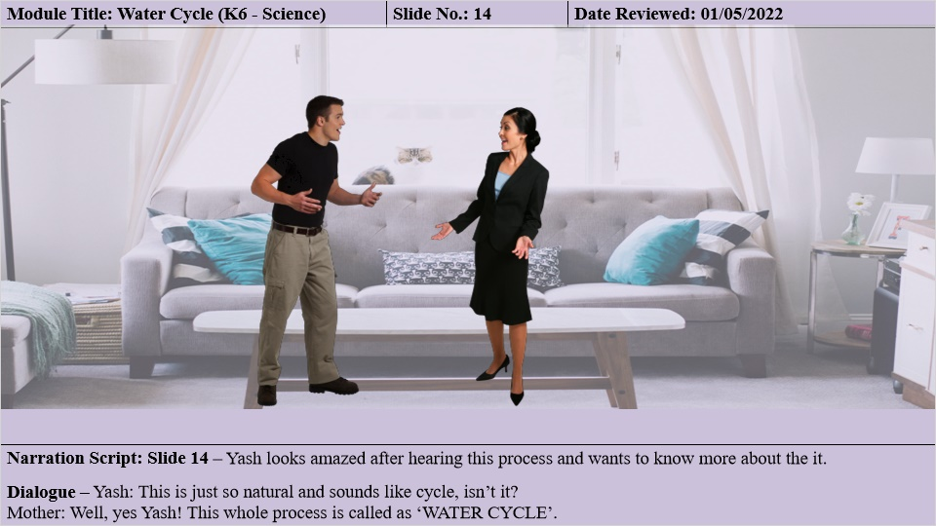

1.16 Slide 16 - Watercycle
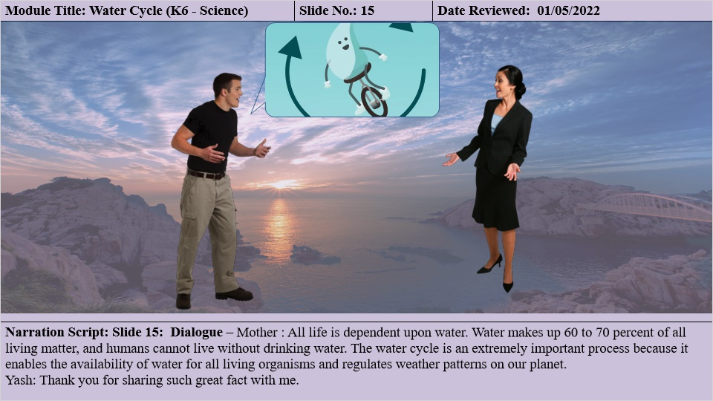

1.17 Slide 17 - Watercycle
